**BCDE102 Assessment 3 Daniel Wild**

**Iteration 5**

**WHERE:**

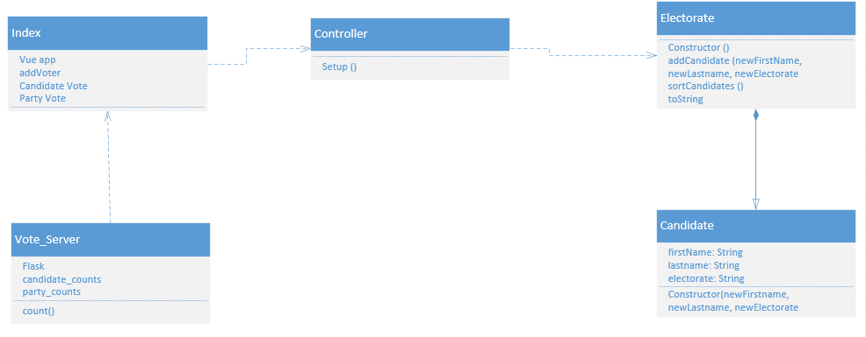

**WHAT:**

The goal of iteration 5 is to build a database in MySQL using either Node.js or Python and connect it to the flask server so that when a vote is cast it is stored in the database that can then be used to create a total votes graph using chart.js

The Tasks:

1. Create the database
2. Link the database to Flask
3. Create total vote graph on HTML site
4. Unit test

Task Time Estimates

1. Create the database : 1 hour
2. Link the database to Flask : 1 hour
3. Create total vote graph on HTML site: 1 hour
4. Unit test: 1 hours

Estimated Total Time: 4 hours

Planned product

Task Times

1. Create the database : 2 hours
2. Link the database to Flask: 4 hours (unfinished)
3. Create total vote graph on HTML site: 0 (Ran out of time)
4. Unit test: 0 (Ran out of time)

Total Time: 6 hour

**How:**

Unit tests

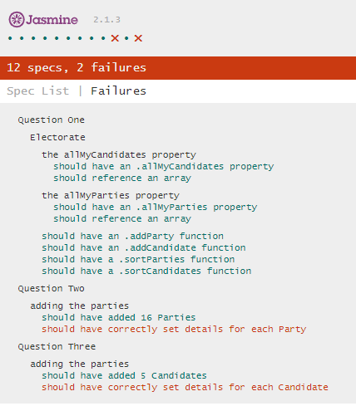JS

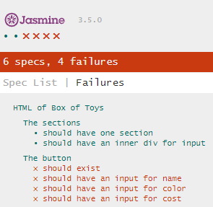HTML

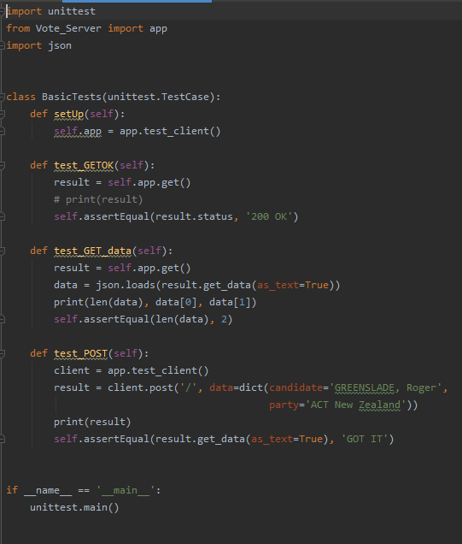Python

User Stories

I am a voter from Wairarapa I want to be able to see the candidates and parties I can vote for. I want to be able to vote for only one of each party and candidate.

I am a new New Zealand voter I want to be able to see the explanation for each vote I am able to make and have a clear form that is easy to read.

I am a vote counter with admin rights I want to be able to see the total number of votes that have been submitted for each candidate and each party.

I am a candidate I want to know what the total number of votes there were and find out who won.

I am a Wairarapa voter who wants to see the results of the last election

I am a vote counter I want votes to be stored and the results be shown in a graph

Burndown Chart

Activity diagram

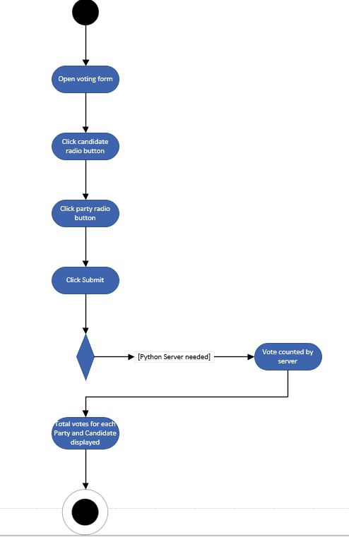

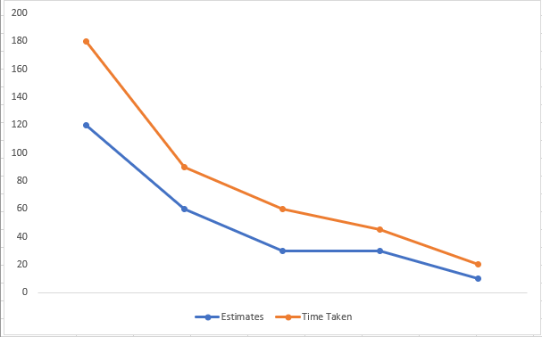

**Evaluation:**

Style

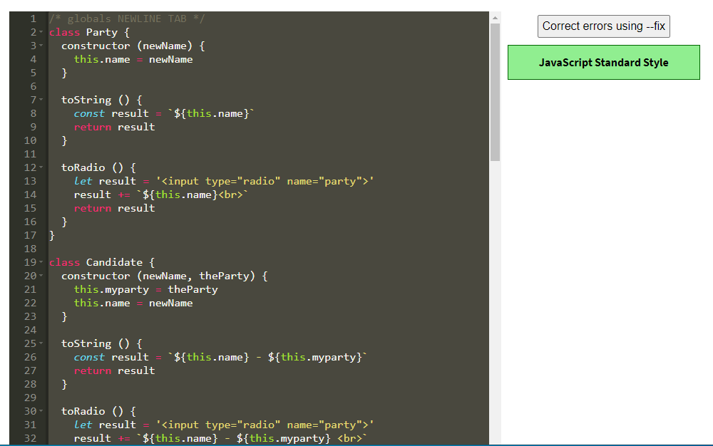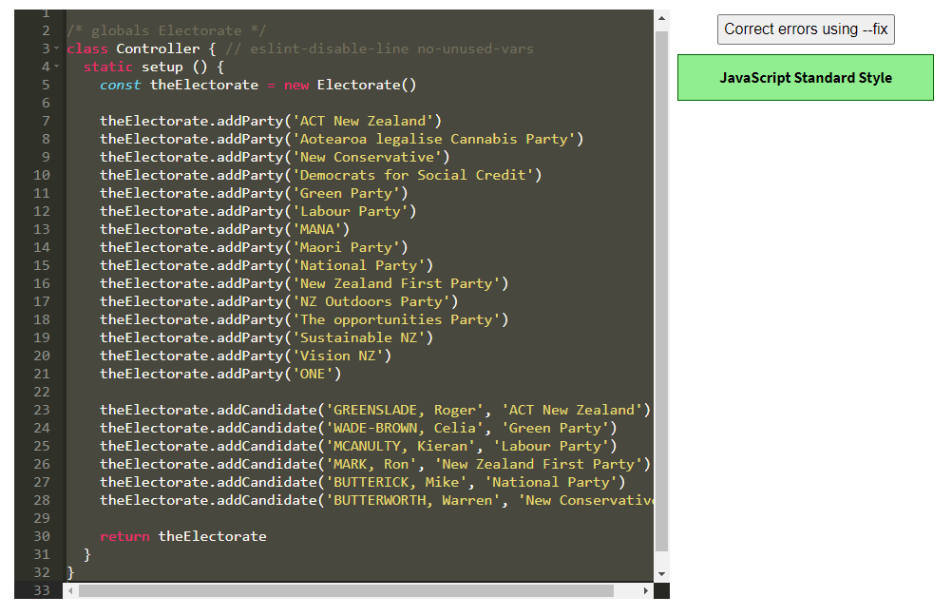 JS

HTML Index.html

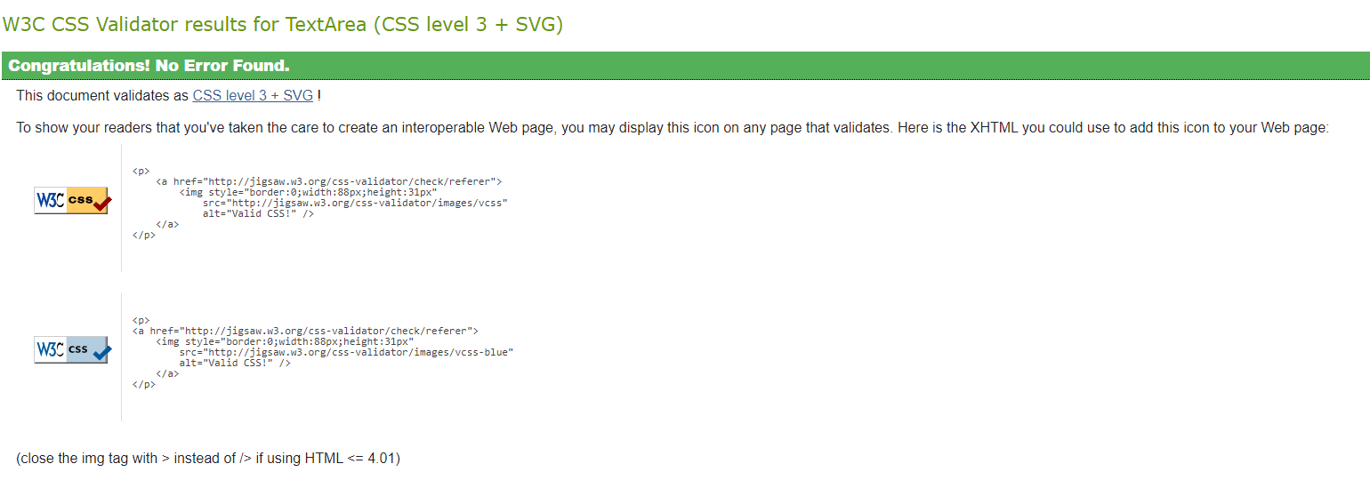HTML Election 2017.html

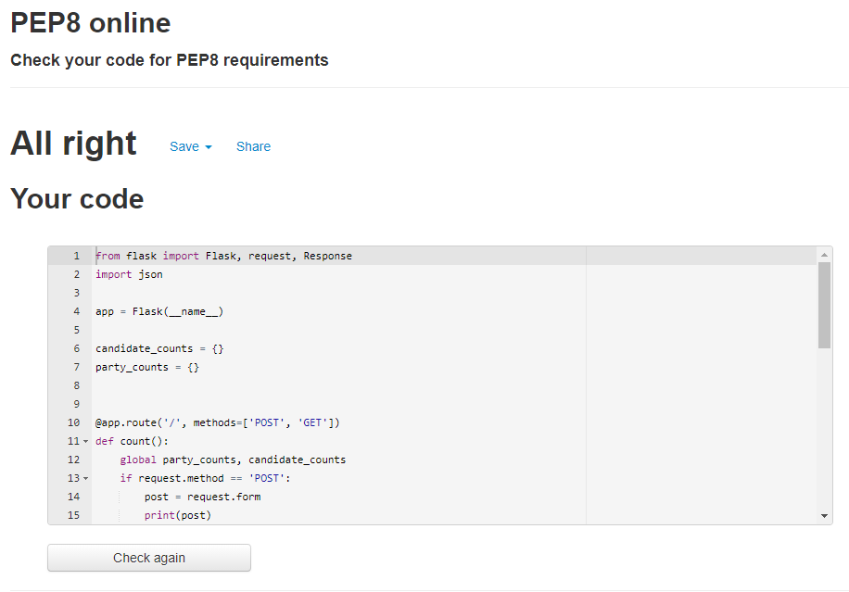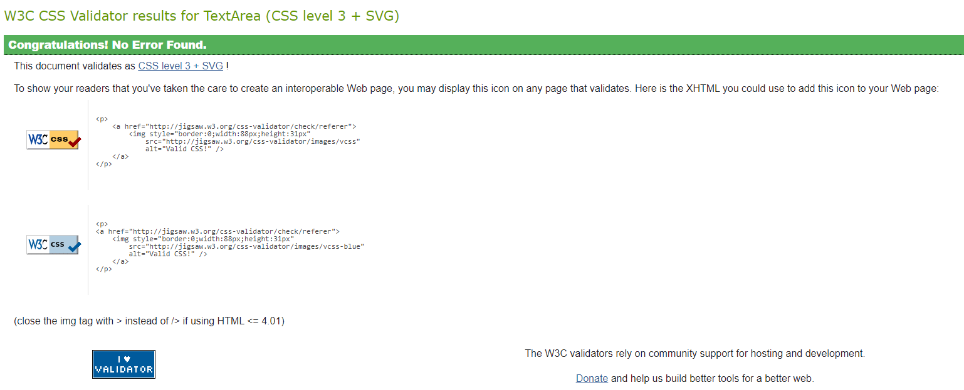Python

**What happened vs what was planned:**

The goal of iteration 5 was to create a database that could connect to the flask server and hold the real time votes so that they could be shown on the HTMl site. I was able to write the code to create the database but unfortunately I was not able to find anyway to get the database to connect to the server so it could not take in the votes and I could not use them to create a graph. I ended up going over the 5 hour work cap so was not able to get this iteration to work and had to abandon the rest of what I wanted to do in this iteration.

**Performance Review:**